**ajax基础练习**

一、用juqery中的$.ajax方法编写邮箱注册查重的网页

代码：

checkemail.php

<?php

$requestemail = $_POST['email'];

$emailArr = array('1219277604@qq.com', '123456@163.com', '110@qq.com');

if(in_array($requestemail, $emailArr)){

echo '该邮箱地址已被注册';

}else{

echo '这个邮箱可以注册';

}

?>

checkemail.html

<!DOCTYPE html PUBLIC "-//W3C//DTD XHTML 1.0 Transitional//EN" "http://www.w3.org/TR/xhtml1/DTD/xhtml1-transitional.dtd">

<html xmlns="http://www.w3.org/1999/xhtml">

<head>

<meta http-equiv="Content-Type" content="text/html; charset=utf-8" />

<title>ajax</title>

<style>

p{

color: red;

}

</style>

<script src="jquery.js"></script>

<script type="text/javascript">

$(function(){

var p = $("#textp");// 显示内容p

$('#emailtx').blur(function(){

$.ajax(

{

url:'checkemail.php',

type: 'POST',

data: {email:this.value},

success:function(data,stutas,xhr){

p.html(data);

}

}

)

});

});

</script>

</head>

<body>

<form>

<input type="text" placeholder="请输入邮箱" id="emailtx"/>

<p id="textp"></p>

<input type="text" placeholder="请输入密码" /><br /><br />

<input type="button" value="注册"/><br />

</form>

</body>

</html>

效果图：

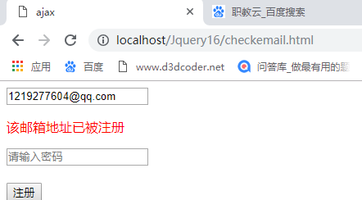

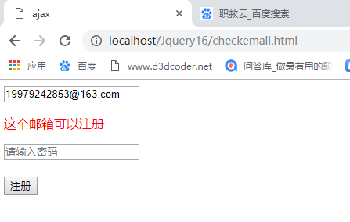

二、编写lol网页

代码：

Hero.html

<!DOCTYPE html>

<html lang="zh-cn">

<head>

<meta charset="utf-8">

<meta http-equiv="X-UA-Compatible" content="IE=edge">

<meta name="viewport" content="width=device-width, initial-scale=1">

<title>lol</title>

<link href="lib/css/bootstrap.min.css" rel="stylesheet">

<link href="lib/css/css1.css" rel="stylesheet">

<script src="lib/js/jquery-1.12.4.js"></script>

<script src="lib/js/bootstrap.min.js"></script>

<!-- core code -->

<script>

$(function(){

$('.getData').click(function(){

var n = $('.heroNum').val();

$.ajax(

{

url:'./api/HeroInfo_List_get.php',

type: 'GET',

data: {num:n},

success:function(data,stutas,xhr){

var iso = data.status;

if(iso == "error"){

alert(data.info);

return;

}

for(var i = 0; i < data.data.length; i++){

var himg = data.data[i].champion_icon;

var hname = data.data[i].champion_name;

var $divs = $('.col-xs-4').first().clone();

$divs.find('img').attr("src", himg);

$divs.find('span').html(hname);

$divs.appendTo('.row');

}

}

}

)

});

// 英雄详情

// 事件委托，对新生成的div也有效

$('.row').on('click', 'a' ,function(){

var gname = $(this).find('span').text();

$.ajax(

{

url:'./api/HeroInfo_details_post.php',

type: 'POST',

data: {name:gname},

success:function(data,stutas,xhr){

// 出现div

$('.modal').modal('show');

// 对控件输入值

$('.jumbotron').find('span').first().text(data.data.champion_title);

$('.jumbotron').find('span').last().text(data.data.champion_name);

$('.jumbotron').find('img').first().attr("src", data.data.champion_icon);

$('.jumbotron').find('p').first().text(data.data.champion_tags);

$('.jumbotron').find('p').last().text(data.data.champion_info);

}

}

)

})

});

</script>

</head>

<body>

<div class="lol-panel panel panel-default">

<div class="panel-heading">

<h3 class="panel-title">lol_英雄_基础版本</h3>

</div>

<div class="panel-body">

<div class="container-fluid">

<div class="row">

<div class="col-xs-4">

<a href="javascript:void(0)" name='' class="thumbnail">

<img src="./api/images/1480473717181.png" alt="...">

<span>卡蜜尔</span>

</a>

</div>

</div>

</div>

</div>

<div class="panel-footer">

<input class='btn btn-info btn-lg getData' type="button" value='加载数据'>

<input class='heroNum' type="text" placeholder="请输入英雄的个数">

</div>

</div>

<!-- 模态框 -->

<div class="modal fade" tabindex="-1" role="dialog">

<div class="modal-dialog" role="document">

<div class="modal-content">

<div class="modal-header">

<button type="button" class="close" data-dismiss="modal" aria-label="Close"><span aria-hidden="true">&times;</span></button>

<h4 class="modal-title">模板页</h4>

</div>

<div class="modal-body">

<div class="jumbotron">

<h1><span>青钢影</span>--<span class="label label-default">卡蜜尔</span></h1>

<img src="./api/images/1480473717181.png" alt="..." class="img-thumbnail">

<p>

tags:战士, 近战 </p>

<p>

卡蜜尔是一位优雅的特工精英，也是一台精密的人形兵器。 </p>

<a class="btn btn-primary btn-lg" href="#" role="button">详细攻略</a>

</div>

</div>

</div>

<!-- /.modal-content -->

</div>

<!-- /.modal-dialog -->

</div>

</body>

</html>

效果图：

